# Rigidbody2D

Mass: 1

Linear Drag: 3

Gravity Scale: 1

Collision Detection: **Continouse**

# Audio

Sync Background Music

Sync Jump Sound

Sync Drift/Friction Sound (with Particle Effect)

# Particle Effect

Sync Drift/Friction Effect (with Audio)

BoBomb

# Animator Controller

## TODO

### Sync Game Mechanic with Animation

Spawn Animation – gravityScale = 0

Spawn finished – gravityScale = 1

Spawn Protection – not Attackable

Rage – not Attackable, kill (Player) and destroy (enemy Projectiles) others by Bodycontact

#### Solutions

##### StateMachineBehaviour

##### Update – check State Machine State

## Layers

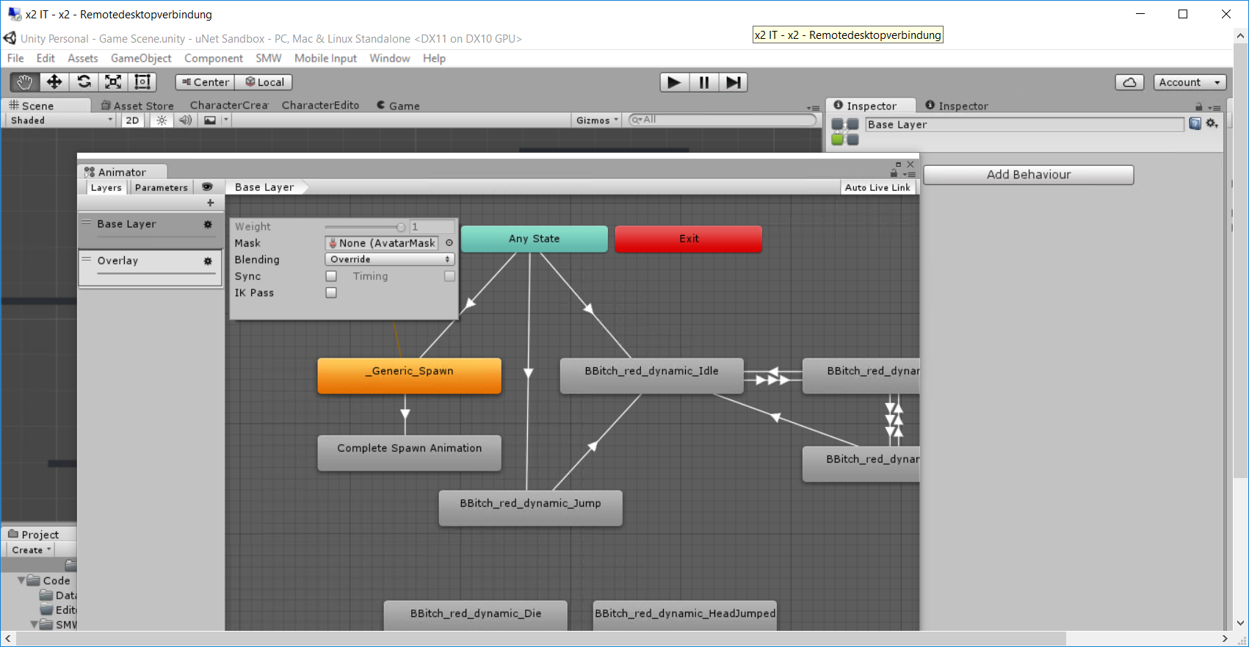

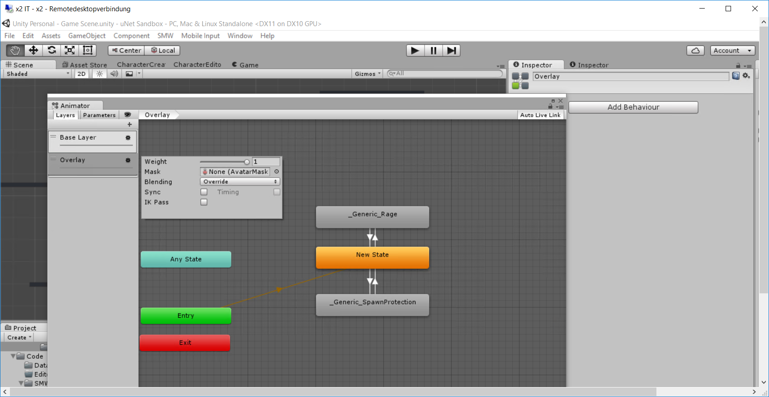



## Transition

### Example: Trigger Rage

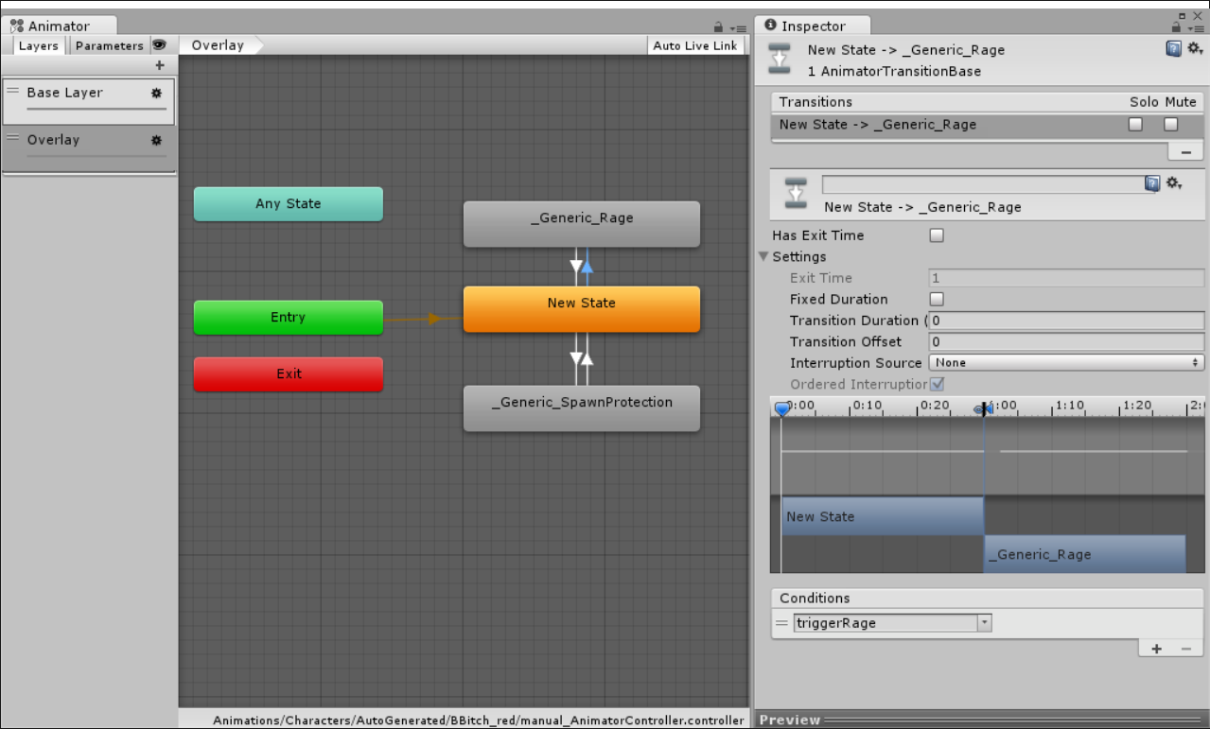

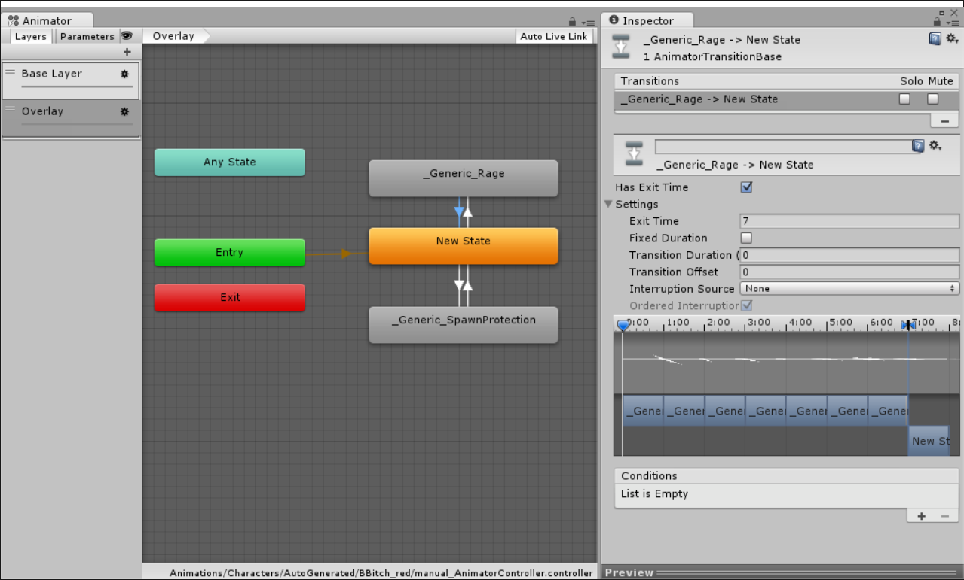

### Has Exit Time

Determines whether the transition’s condition can take effect at any time, or only during the state’s exit time.

If you have “Has Exit Time” selected for the transition and have one or more conditions, the condition(s) will only be checked after the exit time of the state. This allows you to ensure that your transition will only occur during a certain portion of the animation.

### Exit Time

If “Has Exit Time” is enabled, this value represents the time after which the condition can take effect. This is represented in normalised time, so for example an exit time of 0.75 would mean that the transition can take effect only whene when the playback of the current state is more than 75% complete, and the transition’s conditions are met.

### Fixed Duration

<http://forum.unity3d.com/threads/what-is-a-fixed-time-manual-transition.332901/#post-2156572>

With Fixed Duration On : Transition duration is in second

With Fixed Duration Off: Transition duration is in % (normalizedTime)

### Transition Duration

The duration of the transition, in normalised time (relative to the current state’s duration). This is visualised in the transition graph as the portion between the two blue markers.

### Can Transition To Self

Can Transition To Self legt fest, ob nach dem Ziel-State wieder der Ziel-State aufgerufen werden kann. Diese Eigenschaft steht nur bei Transitions zur Verfügung, die von „Any State“ auf einen Ziel-State zeigen.

### Can Transition To Self (only States with Transition from “Any State”)

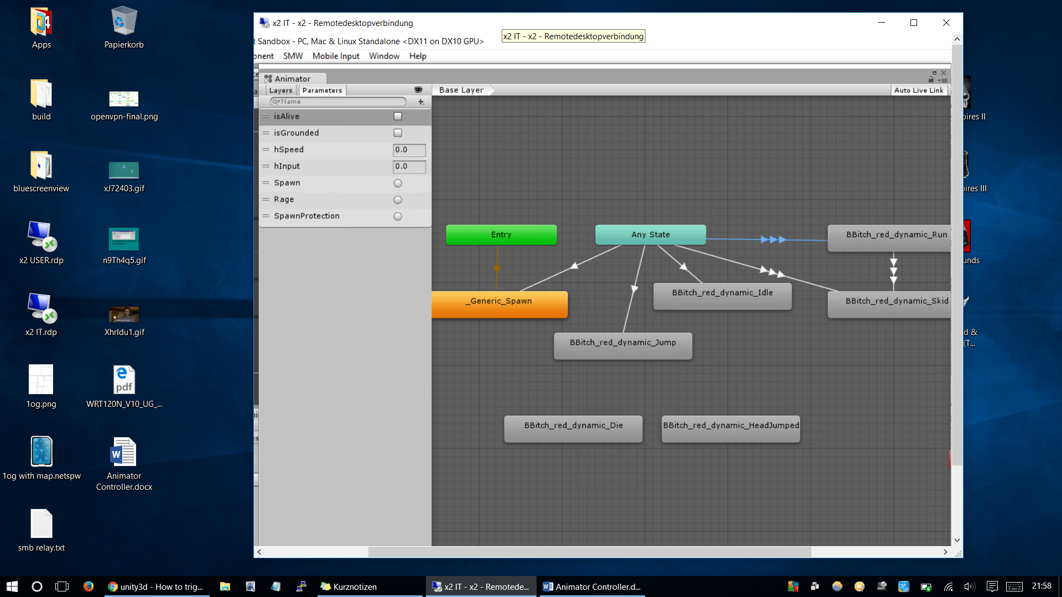

Problem:

Run Animation wird nicht durchgeführt, da sie durchgehend zurückgesetzt wird.

Lösung: **Can Transition To Self deaktivieren**

